**Sorter Game Template**

Modulette ID:

Game #:

Game title: Sorter

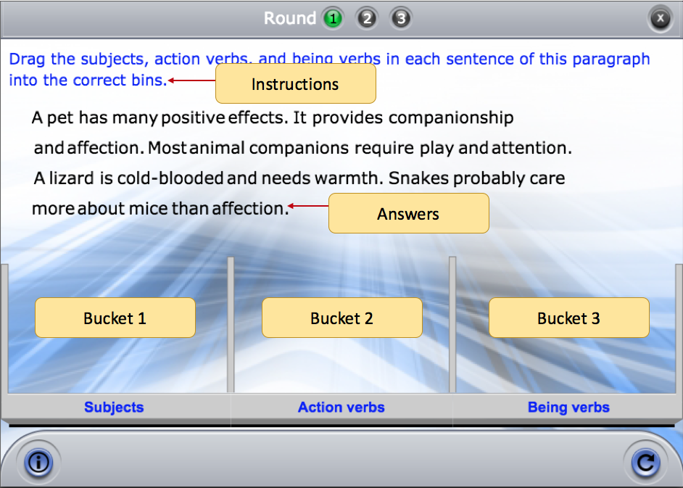

Instructions: [Use if the instructions are the same for the entire game]

Round #

Instructions: [Use if the instructions are the same for the entire game]

Round #

**Instructions:** [Use if the instructions are round specific]

**Image:** [if any]

**Answers:** [Sentence/paragraph/equation whose parts will be sorted]

**Correct Feedback:** [Message to display when everything is correctly sorted]

**General Incorrect Feedback:** [Feedback that will display if no other feedback is defined.]

*Note to authors: Each round can have 2 or 3 bins. If you only use 2 bins, remove the Bin 3 row in the table below.*

|  |  |  |  |
| --- | --- | --- | --- |
| **Bin labels** | **Answers** | **Feedback if the answer in Column 2 is put in ANY wrong bin** | **Feedback if ANY wrong answer is put into this bin** |
| [Bin 1 Label] | [Bin 1 answers] |  |  |
| [Bin 2 Label] | [Bin 2 answers] |  |  |
| [Bin 3 Label] | [Bin 3 answers] |  |  |
|  | Answers that don’t go in any bin |  | ----- |

**Specific answer into specific bin feedback:**

|  |  |  |
| --- | --- | --- |
| **Answer** | **Bin** | **Feedback** |
|  |  |  |
|  |  |  |